**Branch: - Computer Science and Engineering Class: - III Year**

**Subject: - C-Skill Lab-IV Sem: - VI**

**Teacher Manual**

**PRACTICAL NO. 5**

**Aim:** Create and access EC2 instance (Windows OS Instance) with Remote Desktop Application

**Creating an EC2 instance of Windows OS:**

Sign in to the AWS Management Console.

* Click on the EC2 service.
* Click on the **Launch Instance** button to create a new instance.
  + Choose instant name
  + Now, we have different Amazon Machine Images. These are the snapshots of different virtual machines. Enter **Windows** in search bar and hit enter then We will be Windows_Server-2022-English-Full-Base-2023.03.15
  + Choose an Instance Type, and then click on the Next. Suppose I choose a t2.micro as an instance type.(Free Tier Eligible)
  + Create a new key pair and enter the name of the key pair. Download the Key pair.
  + Select Key Pair type RSA and Private Key Format **.Pem**
* Open Remote Desktop Connection.
* Select created Instance and copy Public IPv4 address of those instances. Paste that address in remote desktop connection and click on connect Authentication widow is appeared you have to entered user name and password
* Steps for User name and Password:
  + Select instance click on Connect Instances the click on RDP Clients copy user name from that there User Name: Administrator and select Get Password
  + Upload the key that you have downloaded in Upload Private Key File and then Click on Decrypt Password and copy that password in password tab and Click on Connect

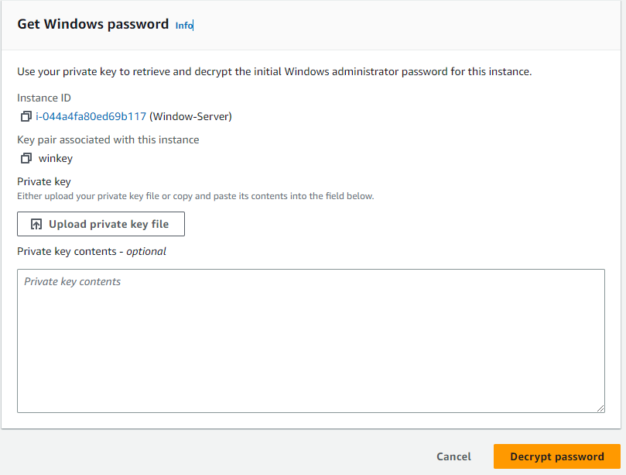

**Password Decryption Windows**

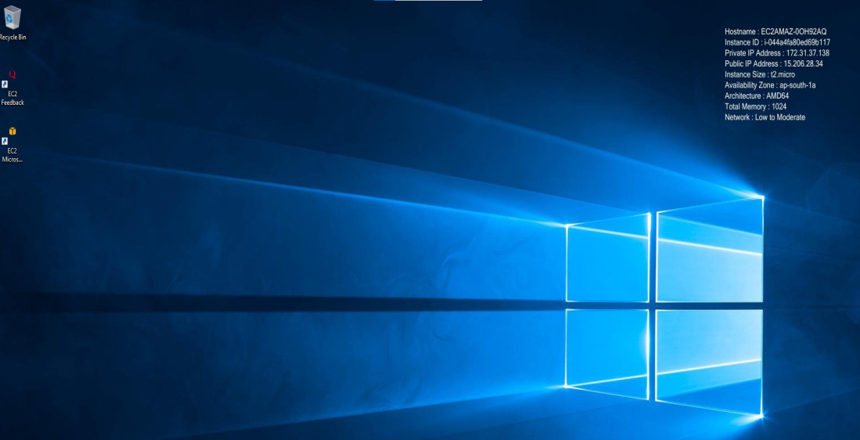

**Windows Virtual Machine Desktop**

**Stop and Terminated an EC2 instance of Linux OS:**

* Select Instance from EC2 Dashboard
* Go to the Instances State tab
* Select Stop Instance
* After Instance services stop then Terminated the instance

**Conclusion:** Thus we have create and access EC2 instance (Windows OS Instance) with Remote Desktop Application